Eating for exam success
Discover what you should eat – and what you should avoid – to help you perform your best during revision and exams.

What to eat during exams
The following top healthy eating tips are from the University of Surrey’s Department of Nutritional Sciences designed to help you stay on top of your game during exam season.

1. Eat proper meals
Meals with slow release carbohydrates will help fuel your revision. When at school during the day, make sure you have a good breakfast and lunch. In the evening, make sure you have a good lunch and dinner.

2. Keep hydrated
Drink plenty of fluid. Go for plain water mainly, with the occasional diluted fruit juice or squash.

3. Eat plenty of fruit and vegetables
Use fruit and veg as a healthy snack instead of crisps, chocolate or fizzy drinks.

4. Watch your coffee intake
Caffeine acts as a stimulant and may aid concentration in small doses (the equivalent of one to two cups) but overdoing the caffeine will dehydrate you, can cause palpitations and may disturb your sleep.

5. Try to avoid energy drinks
High-sugar, high-caffeine drinks may appear to give you an instant buzz but are a poor substitute for proper food and fluid.

6. Avoid too many ‘treats’
Don’t overindulge on fatty foods, sugary snacks (crisps and chocolate) or fizzy drinks.

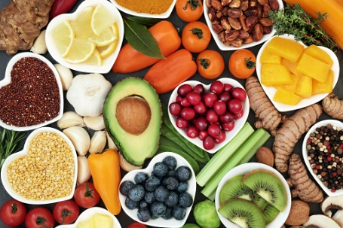
7. Don’t overdo the alcohol
You might feel more relaxed, but alcoholic drinks dehydrate you, disturb your sleep and can wreck your concentration the next day.
8. Pre- Exam Eating
Try to have a light meal before your exam, enough to give you energy through the exam – hence a meal including wholegrain carbohydrate but not too much that you feel sleepy and lethargic.
Ideas for Breakfast
• Porridge and dried or fresh fruit
• Weetabix, shredded wheat, muesli or similar wholegrain cereal and fresh or dried fruit
• Egg (boiled, poached, scrambled, fried) with wholemeal bread or toast
• Yogurt with seeds, nuts and fruit
• Low sugar cereal bar and a glass of milk
Some Smoothie Recipes to power you through the exam season
